GitHub Intro

* Make a GitHub account
* Share with others by making them contributors
* Download and install the GitHub Desktop Client
* Connect it to your GitHub Repository
  + Clone an existing project
* Create and/or change a file
* Commit to master
* Login to GitHub online
  + Go to settings
  + Go to pages
  + Change source to Master Branch
  + Save
  + Find where the site is now published
  + 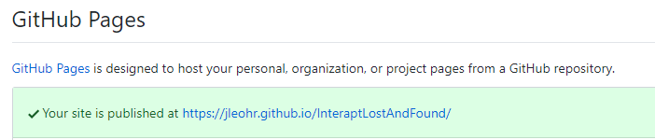
* Click your link and away you go!

Izaak Prats [8:42 AM]

If you're interested in learning more about github: <http://try.github.io>

Online learning resources (these are some good ones):

* <https://www.pluralsight.com>  
  
* <https://www.udemy.com>  
  
* <https://teamtreehouse.com>  
  